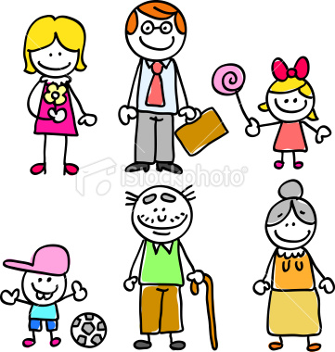

MY FAMILY

This is my _________

This is my _______
This is my _________
This is my _________
This is my _________
This is my _________

